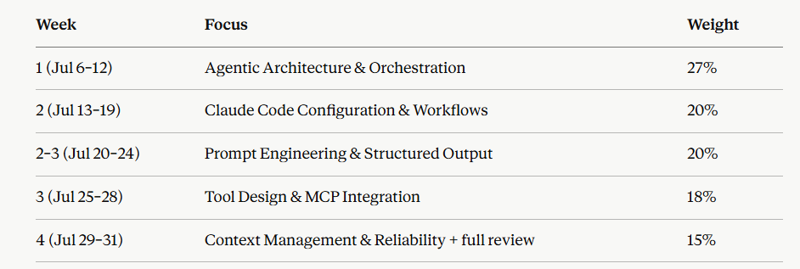

Domain 1 questions

A team builds an agent that monitors a support inbox, drafts replies, and sends them automatically. After a few weeks, they notice the agent occasionally sends replies containing incorrect account information that a human reviewer would have caught. Which change best addresses this without eliminating the automation benefit?
A) Replace the agent with a fixed workflow
B) Add a human-approval step before sending, only for replies where the agent's confidence is low or the reply references account-specific data
C) Increase the model's max tokens so it writes more careful replies
D) Switch to a larger context window
A multi-agent system has a "generator" agent write code and a "reviewer" agent check it. The team notices the reviewer rarely disagrees with the generator, even when bugs are later found in production. What's the most likely architectural cause?
A) The reviewer's model is too small
B) The reviewer agent inherits the generator's conversation context, including its reasoning
C) The reviewer isn't given enough max_tokens
D) The two agents are running sequentially instead of in parallel

A team wants an agent to write a research report: gather sources, synthesize findings, and format the final document. They're deciding whether to split this into 3 separate agents (one per step) or use 1 agent working through all 3 steps in sequence. Which factor should drive the decision?
A) Whether the total task is "big enough" to justify multiple agents
B) Whether later steps depend on nuanced judgment calls made earlier in the process
C) How many tools are available in total
D) Whether the user prefers faster responses

An agent calls a tool to fetch customer order data. The tool call fails with a timeout error. What should the agent's default behavior be, architecturally?
A) Immediately escalate to a human
B) Retry once or twice with backoff, and only escalate/fail gracefully if retries are exhausted
C) Silently skip the step and continue with the rest of the task
D) Terminate the entire task immediately
A company gives an agent full autonomy to modify production database records to "fix" data inconsistencies it finds, with no approval step, because they want maximum efficiency. Six weeks later, they find the agent made several incorrect "corrections" based on flawed assumptions. What's the architectural lesson?
A) The agent should never have write access to anything
B) Autonomy level should scale with the reversibility and blast radius of the action, not just efficiency goals
C) The agent needed a bigger model
D) The agent should have used more subagents to double-check itself

A system needs to handle three very different request types: simple FAQ lookups, complex multi-step billing disputes, and account cancellations that legally require human sign-off. Which orchestration pattern fits best?
- One agent handles all three with the same tool access and autonomy level
B) A router/classifier step directs each request type to a different handling path — direct answer, agentic workflow, or mandatory human handoff — matched to that type's actual risk and complexity
C) Always use the most capable model for all three to be safe
D) Break every request into subagents regardless of type

Domain 2 questions
A team wants to guarantee that Claude Code never runs git push --force under any circumstances, even if a user asks it to. Simply adding "never force push" to CLAUDE.md hasn't been reliable — it's been overridden by direct user requests. What's the correct fix?
A) Make the CLAUDE.md instruction more strongly worded
B) Add a hook that blocks the git push --force command before it executes
C) Switch to a smaller, more literal model
D) Remove Claude's access to git entirely
The generalizable rule for the exam, worth memorizing exactly:
CLAUDE.md / prompts = guidance the model usually follows. Hooks = rules that are always enforced, independent of what the model decides.
Anytime a scenario says "must always," "guarantee," or "even if the user insists" — that's your signal to reach for a hook, not better prompting.
CLAUDE.md is a prompt-level instruction
A large team's codebase has grown to the point where Claude often needs to explore many files just to understand a task, burning significant context before it even starts working. Which Claude Code feature most directly addresses this?
A) A more detailed CLAUDE.md that pre-documents the codebase structure and key file locations, so Claude doesn't need to explore blindly
B) A hook that blocks file reads
C) A slash command that does nothing but greet the user
D) Switching to Plan Mode permanently
A team wants Claude Code to be able to run a specific 5-step database migration checklist consistently whenever anyone asks for a migration, using the same tools and steps every time. They're debating whether to build this as a subagent or a Skill. Which is the better fit?
A) A subagent, because migrations are complex
B) A Skill, because this is a defined, reusable procedure/capability rather than a role requiring isolated reasoning context
C) A hook, because it needs to run automatically
D) A slash command with no arguments
A team wants Claude Code to automatically run their linter after every file edit, and block the edit from being considered "complete" if linting fails — without relying on Claude to remember to run the linter itself. What's the correct mechanism?
A) A CLAUDE.md note reminding Claude to lint after edits
B) A hook triggered after file-edit tool calls, that runs the linter and surfaces failures
C) A subagent dedicated to linting, invoked manually when needed
D) A slash command the user runs manually after every edit
Every Domain 2 question is really asking "does this need to be reliable/automatic (→ hook), reusable/discoverable (→ Skill), isolated (→ subagent), durable project knowledge (→ CLAUDE.md), or safe-exploration-first (→ Plan Mode)?" Match the requirement word in the scenario to the tool built for that exact requirement.

